**Bible Translation Tools**

**Recorder**

**Manual**

**Version 1.4**

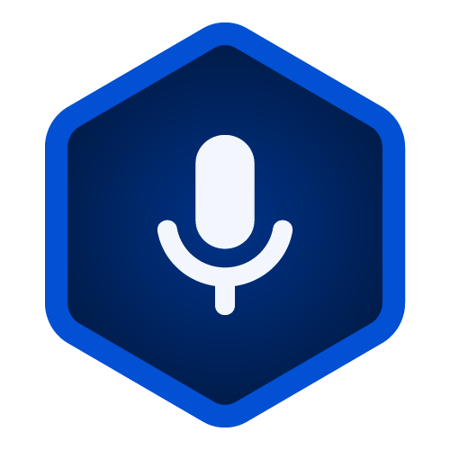

Table of Contents

Introduction - 1 -

Getting Started with BTT Recorder - 1 -

Installing BTT Recorder - 1 -

Installing from the Bible Translation Tools site - 1 -

Installing from the Google Play Store - 2 -

Opening BTT Recorder - 2 -

Creating a New User - 3 -

Creating a New Project - 5 -

Step 1: Select a Target Language - 7 -

Step 2: Select a Project Type - 7 -

Step 3: Select the Recording Mode - 8 -

Step 4: Select the Source Audio (optional) - 9 -

BTT Recorder Main Screens - 12 -

Home page - 12 -

Right side (blue with Microphone icon): - 12 -

Left side (green with List icon) - 13 -

Project Management pages - 13 -

With no projects - 13 -

With existing projects - 13 -

Using the Options Menu - 18 -

Recording screen - 22 -

Opening the Recording Screen - 22 -

Components of the Recording Screen - 23 -

The Recording Process - 24 -

Edit screen - 26 -

Comparing your recording to the source audio - 27 -

Cutting - 28 -

Inserting - 31 -

Placing verse markers - 33 -

Rating - 35 -

Create Chapter Recording - 36 -

Complete the Recording of the Chapter - 36 -

Chapters with a gray Compile icon - 37 -

Chapters with black Compile icon - 39 -

Check the chapter recording - 41 -

Mark the checking level for the chapter recording - 42 -

Sharing Your Project - 42 -

Opening the Information window - 43 -

Export Recordings - 43 -

Export to your tablet as a tr file - 43 -

Export to your tablet as a zip file - 44 -

Export the file to another application - 45 -

Upload Recordings - 47 -

Upload to Translation Exchange - 47 -

Upload to the Citrix Server - 49 -

Appendix a

Edit Screen Icons a

English Source Audio Link b

Translator Handouts b

Video Demonstrations b

Power Point Presentations (with PDFs) c

# Introduction

BTT Recorder consists of several user interface screens to enable you to record and edit oral translations of the Bible or Open Bible stories. Recordings are organized into **projects** that consist of:

* A target language – the language you are translating into
* The project type, such as a book of the Bible or an Open Bible story

A project can optionally use source audio, so that the translator can listen to the source and then record its translation in the target language.

Before you can start recording, there are some steps you need to take:

* Install BTT Recorder
* Open the program
* Create a new user
* Create a new project

The main screens in BTT Recorder are:

* Home page
* Project Management pages
* Recording screen
* Edit screen

# Getting Started with BTT Recorder

There are 4 tasks to perform in order to start using BTT Recorder:

* Install the program
* If BTT Recorder is not open, open the program
* If you have not used the program before, create a new user
* If there are no existing projects, create a project

These tasks are described below.

## Installing BTT Recorder

There are two places to download the program:

* The Bible Translation Tools site
* Google Play Store

### Installing from the Bible Translation Tools site

This option is great if you are planning on leading an event and may not have internet access on site. This may require changes to your device’s permissions. There are benefits to using the downloaded APK:

* Easily transfer the application to multiple devices without internet.
* Can pick a specific version of BTT Recorder, including the most up-to-date version of the program
* Does not require a Google Play Store account.

To install BTT Recorder from the Bible Translation Tools website, perform the following steps:

1. Go to this URL: <https://recorder.bibletranslationtools.org/download/>.
2. Tap **Download APK**.
3. The APK file downloads.
4. Navigate to the download folder.
5. Tap the **bttRecorder.apk file** and allow the program to install. (You may need to give permission for an APK to install on the device.)

### Installing from the Google Play Store

We recommend downloading BTT Recorder directly from the Google Play Store for most people. This requires a reliable internet connection. There are benefits to using Google Play Store:

* Installation is quick and easy
* You will automatically have the most up to date version
* Great for single downloads
* Allows you to run the application on some Chromebooks.

To install from Google Play Store, perform the following steps:

1. Go to this URL: <https://recorder.bibletranslationtools.org/download/>.
2. Tap **Get it on Google Play**.
3. The BTT Recorder app window displays. Tap **Install**.
4. Once installed, tap **Open**.

OR

1. Open Google Play Store on your Android device.
2. Type in ‘BTT Recorder’ in the search field.
3. The BTT Recorder app window displays. Tap **Install**.
4. Once installed, tap **Open**.

## Opening BTT Recorder

If BTT Recorder does not open after installation, or if you have closed it and need to reopen it, just tap the BTT Recorder icon on the device screen.

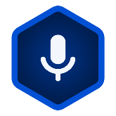

This icon may not be on the main screen; you may need to scroll to a different screen to find it, or open your apps. You can then tap and drag it to the main screen if desired.

The first time you open the program, tap **ALLOW** to grant BTT Recorder access to media files and then tap **ALLOW** to give the program permission to record audio.

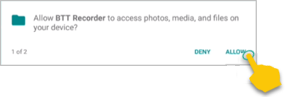 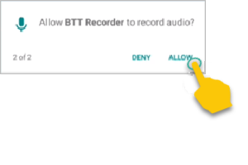

## Creating a New User

To create a new User profile, tap the **New User** card.  
 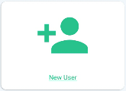

Read, or have someone read to you, the three Terms of Use.

* Tap each of the **green bars**.  
  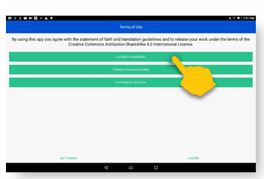
* Read the content. You may need to scroll to see the entire contents of the ‘Translation Guidelines’.
* Tap **Close** at the bottom of each of the windows.

Tap **I AGREE** at the bottom of the window if you agree with all three statements.

Tap the **Microphone icon** and record your name or pseudonym. A pseudonym is a false name that you can use if you are concerned that being associated with Bible translation will compromise your safety or that of your family.  
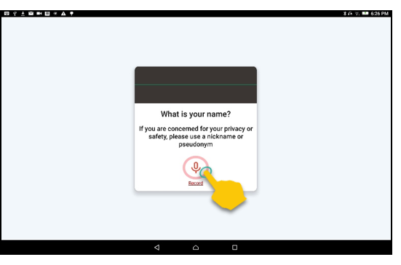

Record your name while the red circle is going around – 3 seconds.

Note the image in the center of the window. This is your identicon. Each user has a unique identicon. Tap the **Play button**  to listen to the recording.  
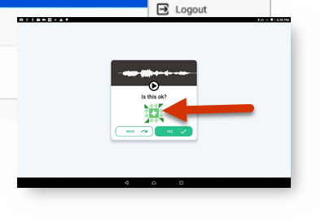

* If you can you hear your voice and understand your words, then tap **Yes**.  
  
* If your voice is too soft or you cannot understand your words, then tap **Redo** to make another recording.  
  

When you accept the recording, the initial screen (home screen) opens and you are ready to get started.

**NOTE**: If you want to create another user, you can log out of the program (see Using the Options Menu)

## Creating a New Project

If you have no existing projects, you will need to create a project before you can work in BTT Recorder to perform oral translation.

You can start creating a new project by one of the following methods:

* If no project is shown in the right blue section of the Home screen, by tapping the right area (recording section) on the Home screen.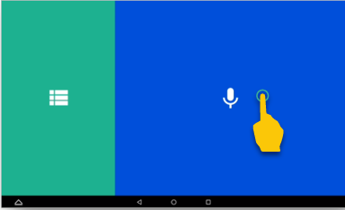
* From the Project Management screen, by tapping the **New Project** button (seen only on a new install) or the **Plus icon**. (You can get to the Project Management screen from the Home screen by tapping in the left green area.)  
  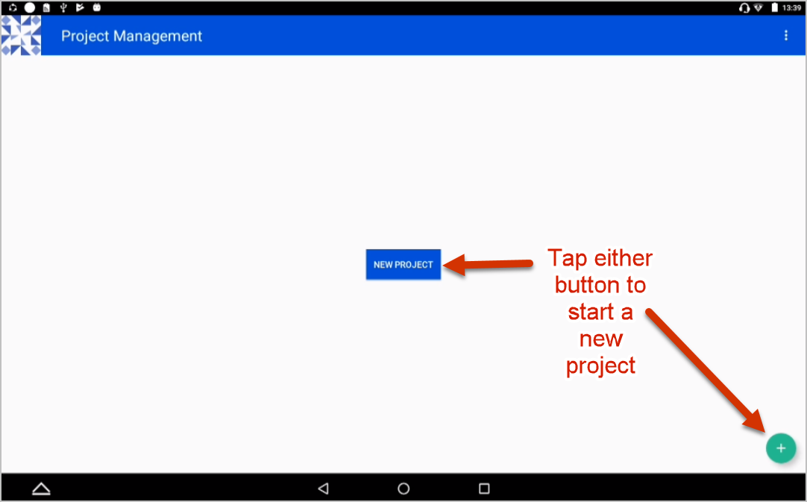

Once you have initiated the project, the steps to define it are the same:

1. Select a target language
2. Select the project type
3. Select the mode of the recording
4. Optionally select a source audio

**NOTE**: During these next steps, you may tap the **back arrow** in the top blue bar to go back to the previous screen at any time. You may want to go to the previous screen to make a different choice.

### Step 1: Select a Target Language

The Target Language is the language into which you will translate.

You can search for your desired language by one of the following methods:

* + Swiping from the bottom of the screen up to scroll through the languages.

OR

* + Tapping the **magnifying glass**. The keyboard appears.
  + Type in the language or language code. Close the keyboard by tapping the **down arrow** icon, or **back arrow** icon.

Tap the name of the desired Target Language. The program advances to the next step.  
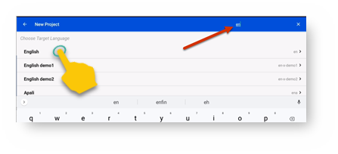

### Step 2: Select a Project Type

The Project type defines what you will be translating from and consists of:

1. What kind of project? Tap to select from the choices of **Bible: Old Testament**, **Bible: New Testament**, or **Open Bible Stories**.  
   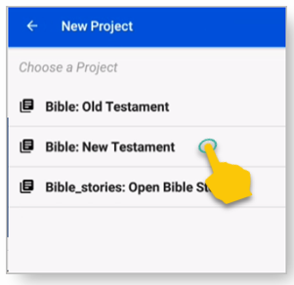
2. Which book or story? Tap a **book in the Bible** or a **Bible story** to translate. Swipe up to see more book or story names.  
   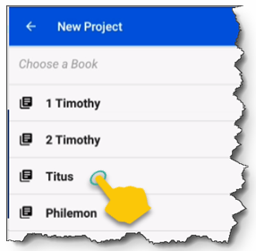 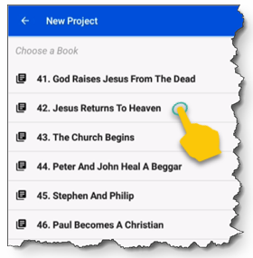
3. If you are translating the Bible, which translation type? If you are translating from the UDB or ULB, tap one of those choices. Otherwise, tap **REG: Regular**.  
   (**Note**: This choice does not apply to Open Bible Stories.)  
   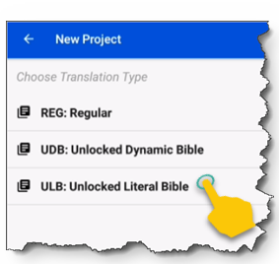

### Step 3: Select the Recording Mode

(**Note**: This choice does not apply to Open Bible Stories.)

This defines whether you will record a verse at a time or a chunk at a time. In most cases, you should record in verse mode.   
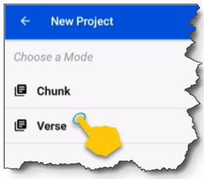

* + Verse mode has each recording separated like a regular Bible, one verse at a time.
  + Chunk mode has each recording separated according to groups of verses.

If you are using source audio, the mode that you select should match that of the source audio.

### Step 4: Select the Source Audio (optional)

If you do not have source audio available, tap **SKIP** in the lower right corner of the screen.  
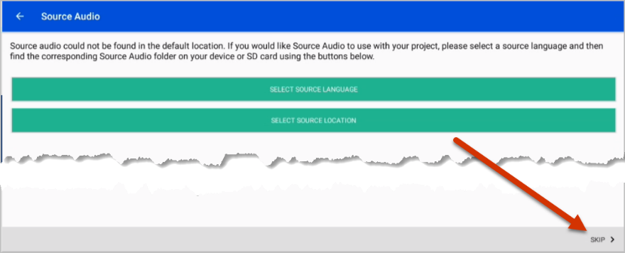

If you do have source audio, you must specify the language and the location of the audio file.

#### Select the source audio language

Tap the top green bar (**SELECT SOURCE LANGUAGE**) to select the language. The Source Language is the language *from* which you will translate.  
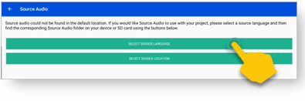  
  
You can search for the desired source language by:

* Swiping from the bottom of the screen up to scroll through the languages.

OR

* Tapping the **Magnifying glass icon**  at the top right of the screen. The keyboard appears. Type in the language or language code.  
  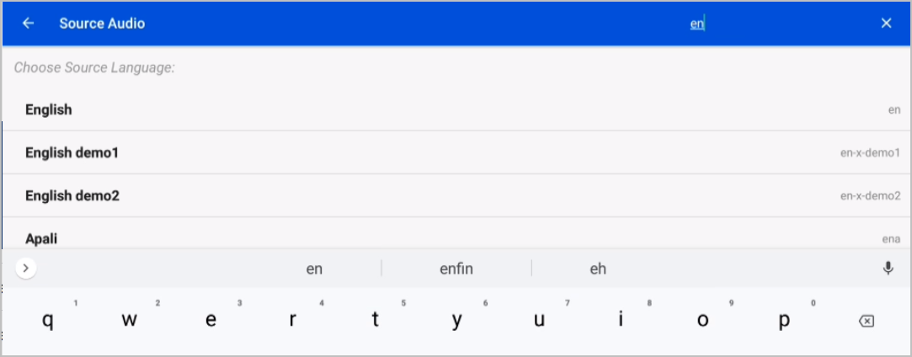  
  You can close the keyboard by tapping your tablet’s **down arrow** icon or **back arrow** icon.  
  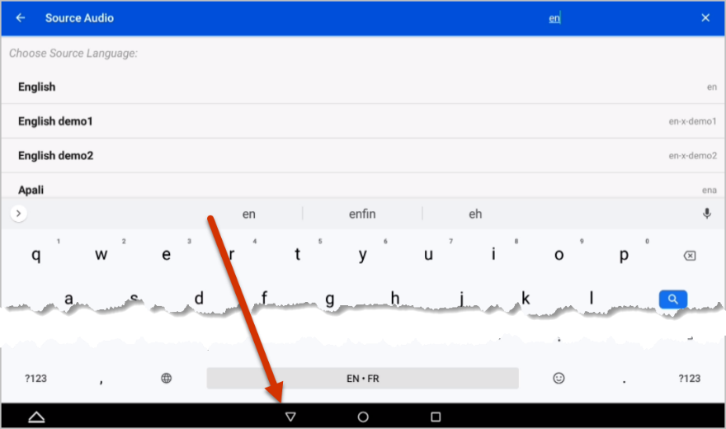

Tap the name of the Source Language. This must match the language of the source audio file. The program goes back to the Source Audio window.  
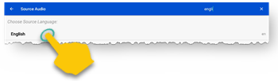

#### Select the source audio file

**NOTE**: The audio files are named as follows: [Language]_[type]_[3-letterbookcode].tr. So, for the ULB audio of the book of Titus in English the file would be named en_ulb_tit.tr.

Tap the bottom green bar (**SELECT SOURCE LOCATION**) to load the source audio.

* The file manager should open to the directory that is set as the default location for source audio.
* If your source audio is not in that directory, you can navigate to the folder where the audio files are located.

**HINT**: You may need to search in the Internal Storage for *.tr files.

Tap the desired source audio file.   
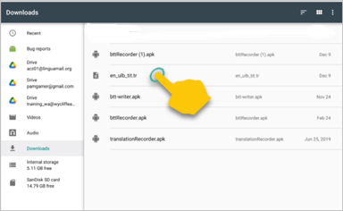  
The program returns to the Source Audio window and displays the location of the source audio file on the lower green bar.

Confirm that the information in the green bar is correct, and then tap **CONTINUE** at the bottom right of the screen.   
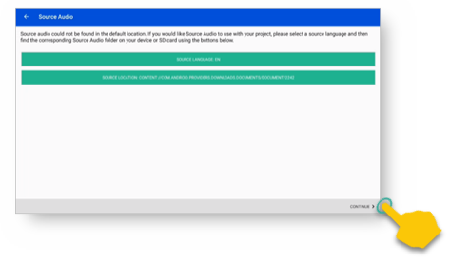

The Recording screen opens. You are now ready to record. Go to Recording screen for instructions on how to record.

# BTT Recorder Main Screens

There are four main screens in BTT Recorder:

1. Home Page
2. Project Management pages
3. Recording screen
4. Edit screen

These four screens are described below.

## Home page

The first time you open BTT Recorder, after you create a user the Home page is shown. The right side of the page is blue with a Microphone icon, and the left side of the page is green with a List icon.

### Right side (blue with Microphone icon):

##### If no project is shown

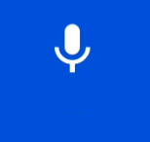

Tap anywhere in this area to start a new project (see Creating a New Project).

##### If project is listed

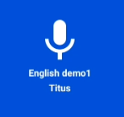

Tap anywhere in this area to navigate to the Recording Screen for that project.

### Left side (green with List icon)

Tap anywhere in this area to navigate to Project Management page.

## Project Management pages

The Project Management page that first opens from the Home page displays a list of existing projects, if any. It also contains a 3-dot icon that enables you to access an Options menu.

### With no projects

If there are no projects shown, you can tap either the New Project button or the Plus icon to start a new project (see Creating a New Project).

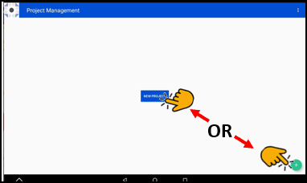

### With existing projects

#### Project list

If you have existing projects, this page displays a list of them. You can also tap anywhere on the project bar to invoke the chapter list (see Chapter list), or you can tap the Plus icon to start creating a new project (see Creating a New Project).   
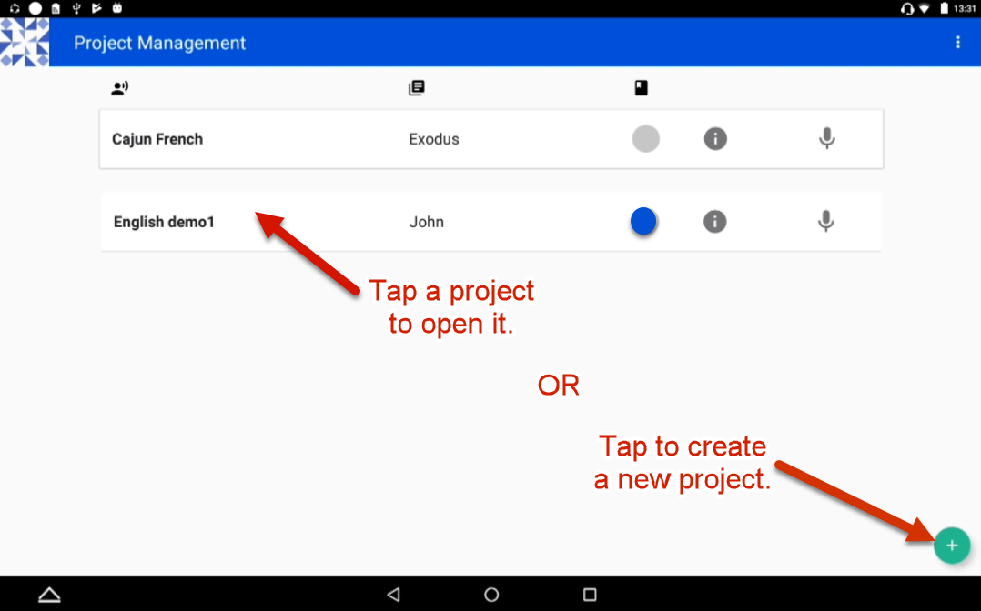

Each project in the list contains 3 columns that describe the project and 2 icons that you can tap.

##### Descriptive columns:

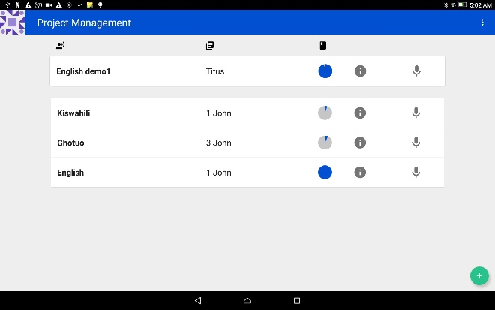

*  Target language – the language you are translating into
*  Project type – the book being translated or recorded
*  Completion status, indicated by a circle that fills with blue as the project progresses

##### Information icon

Tap the Information icon on a project to open a popup window with further details about the project.  
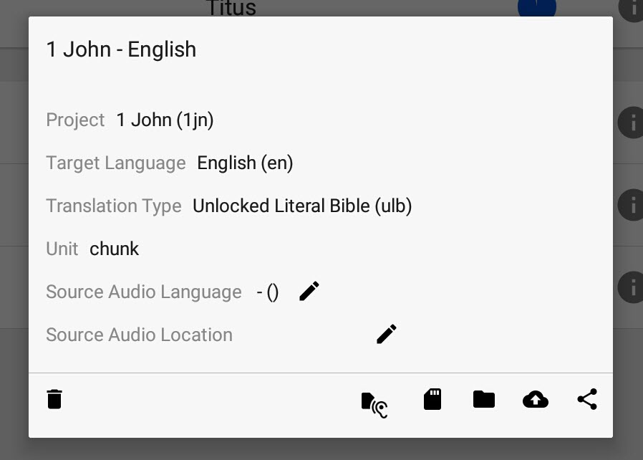

The Book and Target Language are in the title of the Information popup. The window displays the following details:

* Project - The name of the book.
* Target Language - The common name followed by the language code in parenthesis.
* Translation Type - The choice made for the project. (Regular, UDB, or ULB)
* Unit - Either Chunk or Verse.
* Source Audio Language - If source audio is chosen its language is displayed here. You can tap the **Pencil icon** to change the Source Audio language. *
* Source Audio Location - If source audio is chosen its location is displayed here. You can tap the **Pencil icon** to change the Source Audio location. *

*This opens the screen for selecting the source audio (see Select the Source Audio).

Tapping the **Trashcan icon**  at the lower-left deletes your project. The other icons along the bottom right are for sharing your project (see Sharing Your Project).

Tap anywhere outside of the Information popup to close it.

##### Microphone icon

Tap the Microphone icon to start recording the project. It opens the Recording screen to the first verse or chunk of the project.

#### Chapter list

On the Project list, tap anywhere on the project bar to invoke the Chapter list.

On the Chapter list, you can:

* Tap the left arrow at the top left of the window to return to the Project list.
* Tap in the chapter bar to invoke the verse or chunk list.

The Chapter list contains 2 columns that describe the chapter and 2 icons.

##### Descriptive columns:

* Chapter number
* Completion status

##### Compile icon

Tap this icon to compile the individual verse recordings into a single recording for the chapter. See Create Chapter Recording.

##### Microphone icon

Tap to invoke the Recording screen for this chapter.

#### Verse/chunk list

On the Chapter list, tap in the chapter bar to invoke the Verse or Chunk list for that chapter.

On the Verse/Chunk list, you can tap the left arrow at the top left of the window to return to the Chapter list.

Each verse or chunk is recorded separately, and you can record multiple takes of each verse or chunk. You can rate the takes to determine which one is used when you compile a chapter recording.

The Verse/Chunk list contains 2 columns that describe the verse or chunk and 2 icons.

##### Descriptive columns

* Verse number (or numbers if in chunk mode)
* Number of takes (if more than one)

##### Microphone icon

Tap the Microphone icon to record a new take of the verse or chunk. See Recording screen.

##### Right arrow

Tap the right arrow to display the Take bar for the verse or chunk

##### Take bar

A take is one recording of a verse or chunk. Each verse/chunk may have multiple recordings. There is not a separate page to show the takes. Instead, they are displayed in a bar under the verse or chunk, and you can navigate between them by using the left and right arrows. The components of the Take bar are:

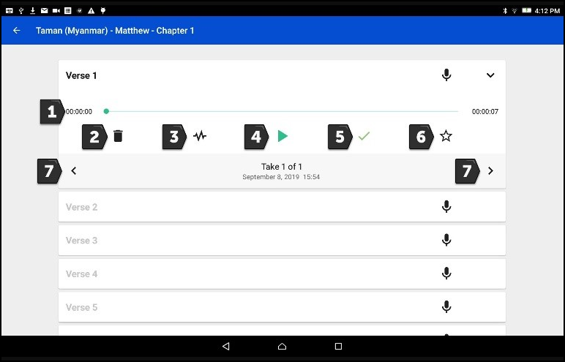

1. The timeline of the length of the audio take. The line expands left to right as the audio take plays. The time at the right shows the length of the recording; the time at the left increments as the recording plays.
2. Garbage can icon - Delete a selected take.  
   **NOTE:** The numbering of the takes changes to reflect the lower number of takes available.
3. Waveform icon - Invoke the Edit screen to edit the take (see Edit screen).
4. Play icon - Play the recording. Tap the Pause icon (replaces the Play icon) to stop playing the recording.
5. Checkmark – Tap to turn green, or if green, tap to turn black. The green color means that the take is approved to use when compiling a chapter recording. When the take is rated 3 stars, this checkmark is green, or you can just tap it to turn it green. Only one take per verse or chunk can be marked with a green checkmark.
6. Star icon - Rate the recording. Only one take per verse or chunk can be rated three stars, indicating the take that is approved to use when compiling a chapter recording.
7. Left or right arrow - Navigate among takes for a verse. Notice that the take number changes.

### Using the Options Menu

The 3-dot menu (Options menu) appears only on the Project Management screen’s Project list and can be found at the far right on the top blue bar. Tap the 3 dots to invoke the Options menu.  
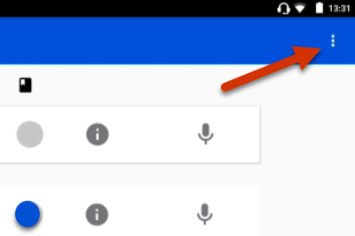

On the options menu you can tap one of the following menu options:

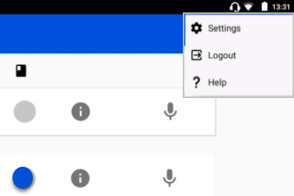

* **Settings** – View or change the settings of the program.
* **Logout** – Sign out of the program. The program restarts at the User Account screen.
* **Help** – View this documentation on how to use the BTT Recorder program. An internet connection is necessary to view the documentation.

#### Settings window

The **Settings window** is mostly for information purposes. You can invoke the Settings window by tapping the **Settings** option in the Options menu. Although you can change some of the settings, it usually is not necessary.

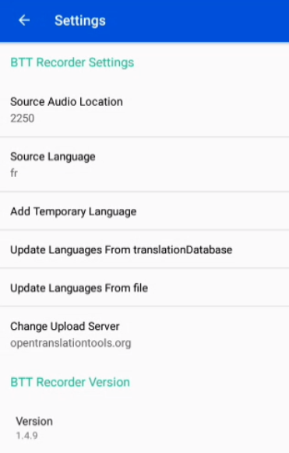

The Settings window contains the following information:

* **Source Audio Location** – Sets the default folder that opens when you select a source audio location for a project. Although you can set the value here, the default location changes if you select a different location when defining a project.
  + - Tap to open
    - Choose **BTT Recorder** and tap **ALWAYS** so that you never have to make the choice again. The window closes.  
      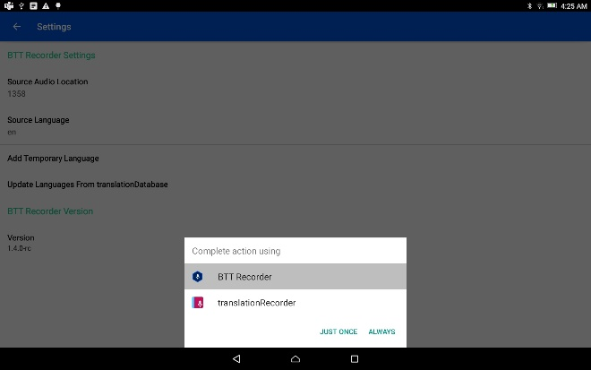
    - A file manager window opens so that you can navigate to the location of the file to use as source audio. Tap the file.   
      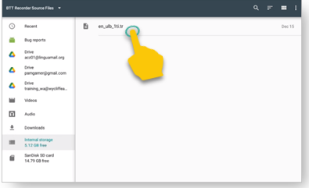
    - The window closes. The next time you define a project’s source audio, the file manager opens to this location.
* **Source Language –** It is not necessary to set a source language, because even if it is set you still need to define it each time you create a project.
  + - Tap to open
    - Search for the language from the list of languages.
    - Tap the language name. The window closes.  
      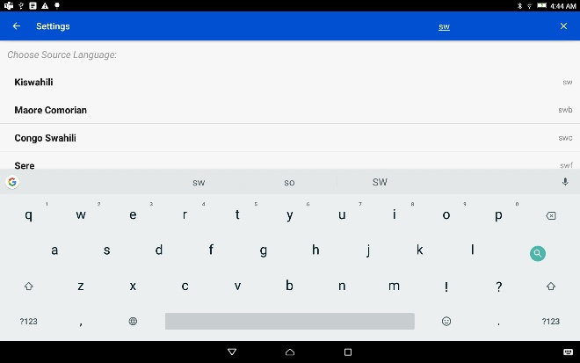
* **Add Temporary Language** – Adds a language to the target language list that displays in BTT Recorder. You may need to do this if your target language does not appear in the target language list.
  + - Tap to open
    - Enter the language name
    - Enter a code of exactly 6 characters
    - Tap **ADD** to add the language and close the window.  
      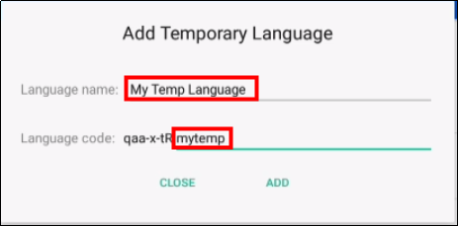
* **Update Languages From translationDatabase** – Updates the list of target languages that displays in BTT Recorder.  
  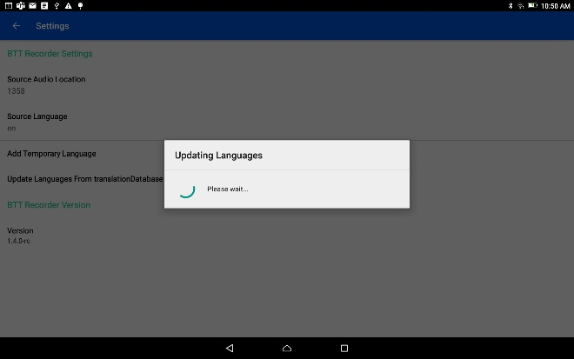
  + - Tap to run the update
    - The update processes
    - The pop-up message window closes when the update completes, and a success message briefly displays.
* **Update Languages From file** – A file manager opens to enable you to locate the file to use.
* **Change Upload Server** – Tap to change the server to which recording projects get uploaded.
* **BTT Recorder Version** cannot be changed. It is displayed for information only.

Tap the **back arrow** at the top left of the Settings window to return to the Project Management screen.

## Recording screen

The recording screen enables you to record a take of a single verse or chunk.

### Opening the Recording Screen

For existing projects, you can navigate to the Recording screen by tapping the **Microphone icon**  on either the Home screen (if there is a project listed) or any of the list views of the Project Management screen.   
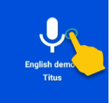 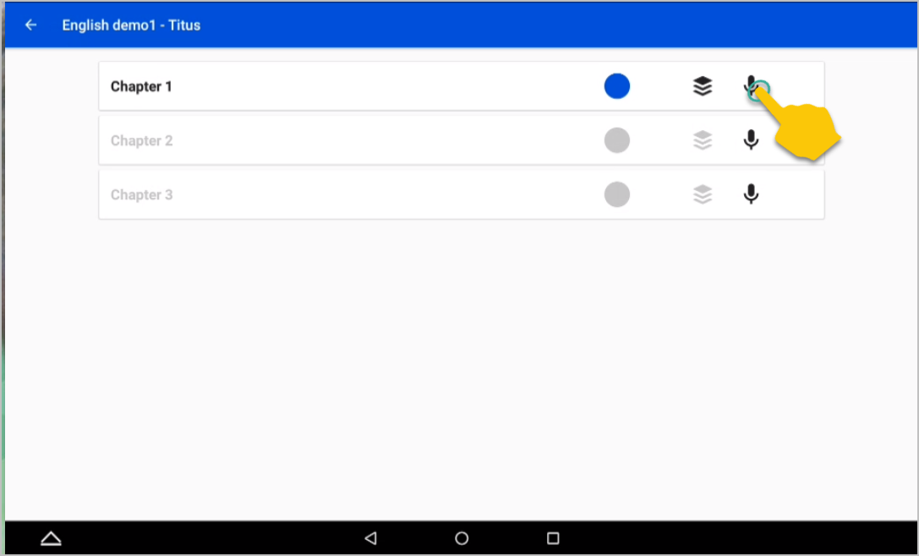

If you are still in the Source Audio screen after creating a new project, tap **CONTINUE** in the lower right of the window to open the Recording screen for the new project.  


The Recording screen is initially set to a certain verse/chunk, depending on how you opened the Recording Screen:

* If you opened the Recording screen from the Home screen or from the Project list of the Project Management screen, the Recording screen initially shows Chapter 1 and verse/chunk 1 of the project.
* If you opened it from the Chapter list of the Project Management screen, the Recording screen is initially set to verse/chunk 1 of the chapter whose microphone you clicked.
* If you opened it from the Verse/chunk list of the Project Management screen, the recording screen shows that verse or chunk.   
  **Note:** This is the preferred method, because the Verse/chunk list shows you whether that item has been recorded already, so that you don’t unintentionally duplicate your work. It is also an easy way to navigate to the specific item that you want to record.  
  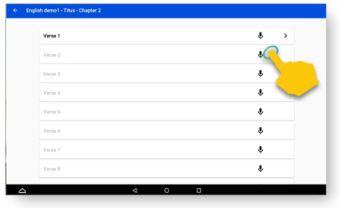  
  **Note:** Verses or Chunks that have recordings are dark black. Verses or Chunks that have no recordings are gray

### Components of the Recording Screen

The Recording screen contains the following elements:

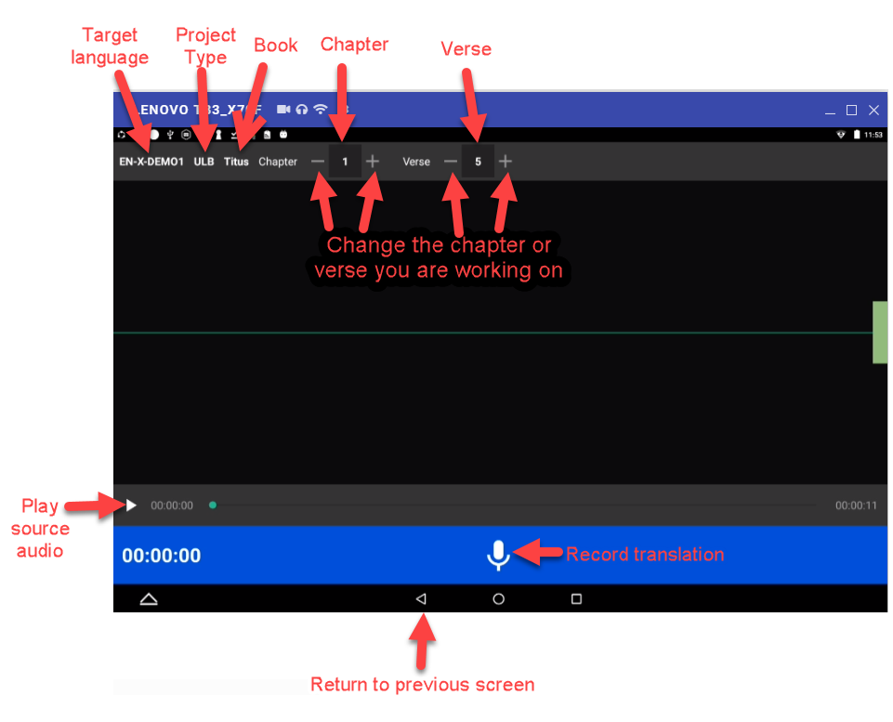

* Top bar: Displays project information, chapter number, and verse/chunk number, with + and = icons to change the chapter and/or chunk/verse numbers.
* Play icon to play the source audio, if you are using source audio (changes to Pause icon to stop/pause listening).   
  If you do not see the Play icon, you do not have source audio or have not defined it correctly (for example, you may not have created your project with the same verse or chunk mode as the source audio.)
* Microphone icon to begin recording translation (changes to Pause icon to stop/pause recording)

### The Recording Process

If there is source audio, you can listen to it as needed to consume the ideas. You may need to replay the source audio more than once before you are ready to record the translation.

To play the source audio, perform the following steps:

1. Tap the **Play icon**  to listen to the source audio.  
   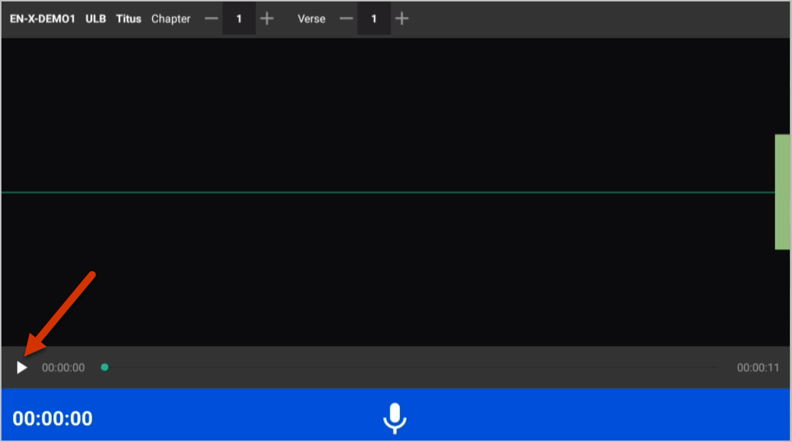
2. Tap the **Pause icon**  to pause the source audio.  
   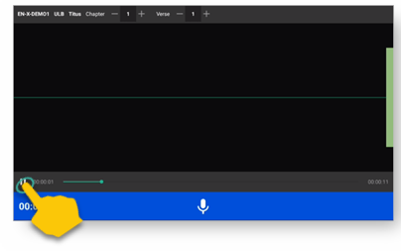
3. Tap and hold the **green dot** and drag it to move to a different position in the source audio.  
   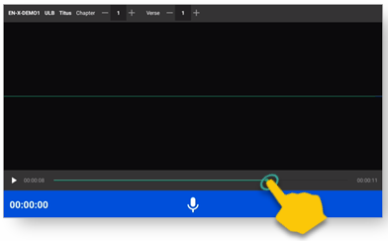

To record the oral translation, perform the following steps (be sure to record only one chunk or verse at a time):

1. When you are ready to record, tap the **Microphone icon** .
2. Record the verse or chunk. As you begin to speak you will see lines appear on the screen, which is the result of the sound of your voice. These lines are known as waves, and the entire line is called a waveform.
3. To pause or stop recording, tap the **Pause icon** .   
   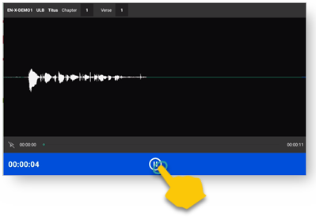
4. If you want to record more, tap the **Microphone icon** to resume.
5. Tap the **Checkmark icon** when you are finished, or if you don’t want to save that recording, tap the device’s Back button to return to the screen where you opened the Recording screen.   
   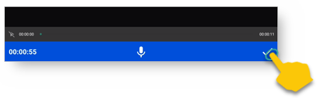
   1. If you tapped the **Checkmark icon**, the program advances to the Edit screen, where you can edit the recording or tap the **Save icon** to save it.
   2. If you tapped the back button, tap the **Trashcan icon** to delete the recording or the **Arrow icon** to continue in the Recording screen.

## Edit screen

A take is a recording of a verse or chunk; a verse/chunk can have multiple takes. Immediately after recording a take, the program automatically advances to the Edit screen. You can also navigate to the Edit screen for a completed take by tapping the Waveform icon on the Take bar of the Verse or Chunk list.

The edit screen enables you to edit the take of a verse or chunk in the following ways:

* Compare your recording to the source audio
* Cut out sections of a recording
* Insert new sections into a recording
* Place verse markers
* Rate the recording

See the `"Edit Screen Icons" document (<https://github.com/WycliffeAssociates/btt-recorder-docs/raw/master/appendix/BTT-Recorder_Edit_Screen_Icons_v1.4.pdf>) for the list of icons and their names.

### Comparing your recording to the source audio

If you have source audio, you can compare the target language recording to the source audio to see what, if anything, needs to be changed in your translation. Perform the following steps:

1. Tap the Ear icon  to switch to Source Audio.   
   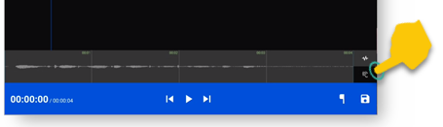
2. Tap the **Play icon**  on the gray bar.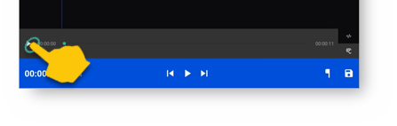
3. To pause the recording tap the **Pause icon**  on the gray bar (the Pause icon replaces the Play icon when the audio is playing.)   
   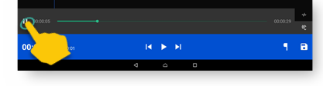
4. To rewind (go towards the beginning of the recording) or fast forward (go towards the end of the recording) tap and hold the **green dot** and slide your finger to the left for rewind or to the right to fast forward.  
   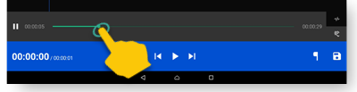
5. To return to your recording, tap the **Waveform** icon. 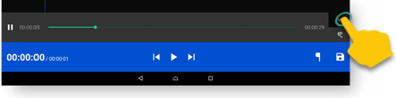
6. Then, listen to the recording:
   1. To playback your recording, tap the white Play icon  on the blue bar.   
      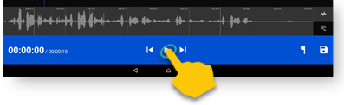
   2. To pause the playback of the recording, tap the **Pause icon**  on the blue bar. (The Pause icon replaces the Play icon.)
   3. To rewind to the beginning of the recording or go to the end of the recording tap the Rewind  or Forward  icon.   
      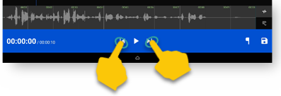
7. Tap between the source audio (**Ear icon** ) and target language (**Waveform icon** ) playback to compare the entire recording.

### Cutting

The action of removing a section of a recording is known as a ‘cut.’

There are 2 ways to mark a section for deletion::

1. One way is to use the upper waveform window:
   1. Position the audio at the thin blue line for the beginning of the recording to be removed.  
      **NOTE**: The blue line does not move. You will need to do the tap-and-hold action to move the recording to the blue line.  
      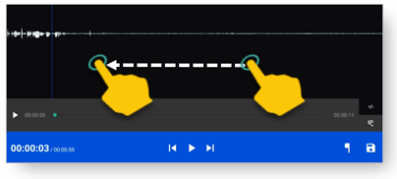
   2. Set the beginning point of the cut by tapping on the **Flag icon** . This inserts a marker where the cut will start.  
      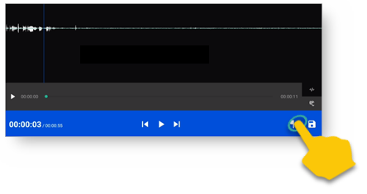
   3. In the upper waveform window, drag the recording by holding your finger on the screen and sliding to the left until the end of the part to be removed is at the blue line. Alternatively, tap the **Pause icon** while listening to the recording when you reach the end of the section to cut.
   4. Tap the upside-down flag icon  to mark the end of the section for deletion.  
      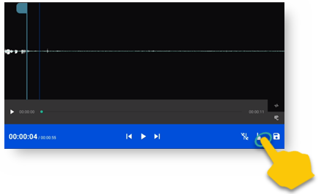
2. The second way to mark a section for deletion is by using the entire waveform that is displayed in the lower section of the window.
   1. Tap and hold where you want the deletion to begin and drag to the end of the deletion.
   2. As you do so, the marked area is shown in both the upper and lower waveform areas and the flags are inserted automatically.  
      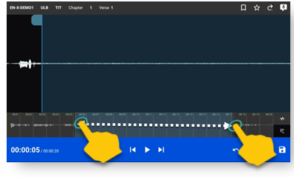

**OPTIONAL**: Tap the play icon to listen to the section that will be removed.

**Do you want to change the amount of recording that is selected?** Tap-hold-drag on the **upside-down flag** to increase or decrease the amount of the selected recording.

**Need to start again?** Tap the **Crossed-off Flags icon**  to remove the flags and start at step 1.

Now that you have marked the correct section for deletion, you can:

* Cut the selected section of the recording by tapping the **Scissors icon**.  
  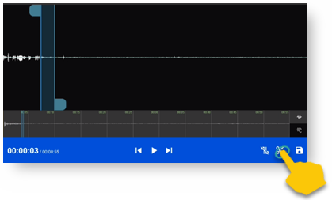
* **OPTIONAL:** Tap **Play** to listen to the take to ensure it is correct.
* If you made a mistake, tap the Undo icon  to restore the deleted section.  
  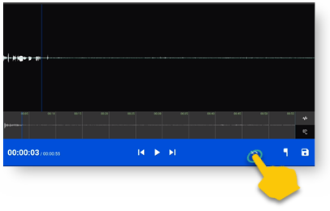
* When the take is correct, tap the **Save icon ** to save the edit. BTT Recorder saves the edited take and returns to Project Management.

### Inserting

Sometimes you may want to insert a missing part into the translation. For example, to re-record a section of the take, you can first cut it and then insert the replacement for the section.

To insert a section into the recording, perform the following steps:

1. Position the audio at the thin blue line for where the new audio will be added in (use the tap-hold-drag action, or tap in the lower waveform, or listen to the recording and tap **Pause** when you are at the correct place.)
2. Tap the **Add a Recording icon**  in the top gray bar. This opens a new recording session for the part to be inserted.  
   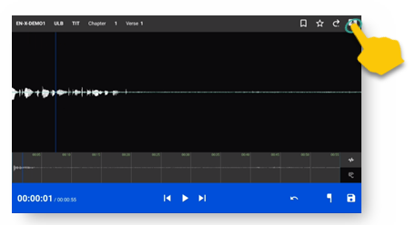
3. The bar at the bottom of the window is green. Tap the **Microphone icon**  to start recording.  
   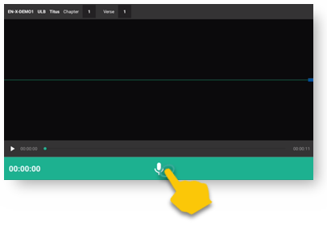
4. When finished, tap the **Pause icon** , or if you need to pause while recording, you can tap Pause and then tap the microphone to resume.
5. To insert the new recording, tap the **Checkmark icon** .
6. A pop up appears stating it is inserting recording … please wait.
7. The original target language recording opens with the inserted recording added.
8. To save the file tap the **Save icon.**   
   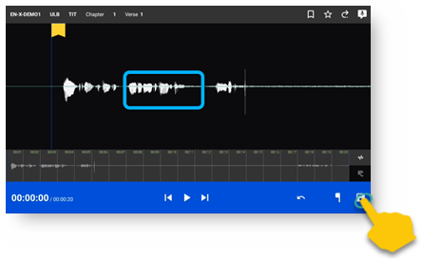

Once the program is done saving, the Project Management verse/chunk list screen opens with a new take added at the bottom of the take list. For example, if there were 3 takes before recording the new section, the added take is Take 4.

### Placing verse markers

Verse markers are available only when recordings are done in chunk mode. To insert the verse markers, perform the following steps:

* Open the recording in the Edit screen.
* Tap on the **Bookmark icon** .   
  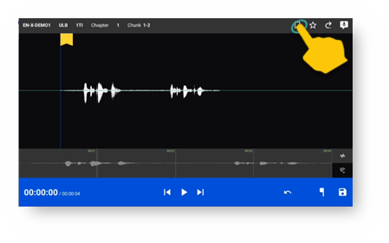
* The Verse Marker window opens.
* Notice the yellow playback bar on the bottom of the window.
* The top gray bar has the number of markers left to put into place.
* A verse marker is at the beginning of the recording.
* Locate the end of the verse:
* Tap the **Play icon** to play back the recording.  
  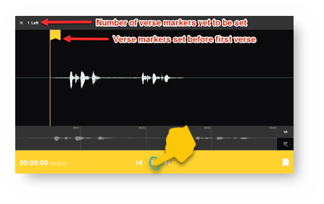
* Tap the **Pause icon** to stop the playback when it is at a verse ending.
* Other ways of finding the correct spot in the recording:
* Use the tap-hold-drag action to move the playback forward or backward until the verse division is on the blue line.
* Tap in the bottom waveform.
* To add the verse marker, tap the **Verse Marker icon**  at the bottom right of the screen.  
  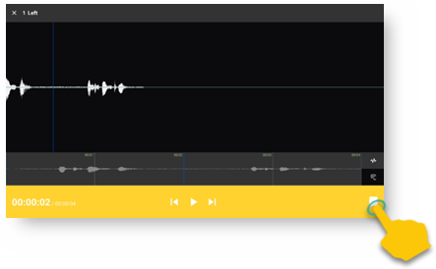
* If there is another verse to mark: Continue to listen to the playback for the next ending of a verse.
* You can use the tap-hold-drag action to move a verse marker flag forward or backward on the waveform.
* When there are no more verse markers to place – tap the **X icon**  at the top left of the window, just to the left of where it tells you the number of markers left to be placed.  
  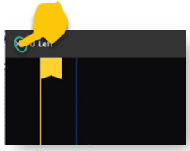
* The verse markers are shown on the Edit screen. Tap the **Save** icon at the bottom right of the screen to save and return to Project Management.  
  **HINT**: you might want to rate this recording before saving.

### Rating

To indicate the quality of the recording, you can add a star rating to it. The star ratings are used for the program to determine which take of a verse or chunk to use when compiling an entire chapter recording (see Create Chapter Recording).

1. Tap the Star icon  (either on the verse/chunk bar or in the top gray bar of the edit window). The “Rate this take” window opens.  
    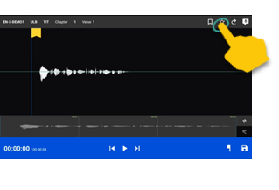 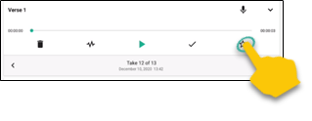

* Tap the left star if the recording is not the best – the star turns red.  
  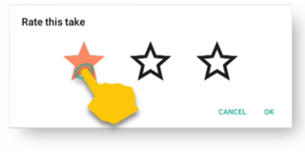
* Tap the middle star if the recording is fine but could be better – the stars turn yellow.  
  
* Tap the right star for an excellent recording – the starts turn green. Only one take per verse/chunk can be rated 3 stars, because this indicates the accepted take.  
  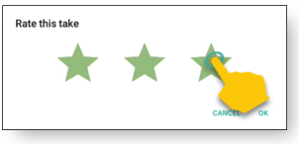

1. Tap OK to save.

# Create Chapter Recording

After the verse or chunk recordings have been created for a chapter, it is then possible to combine them to make a recording into a complete chapter. The translator can listen to the entire chapter and make additional edits if necessary.

Terms to know:

* **Compile** – to put into one piece, combine.
* **Stitch** – to combine the different recordings into one recording.

## Complete the Recording of the Chapter

1. Start in the Project Management screen and tap the project to work on. 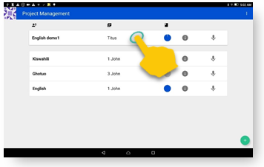
2. The circle should be full, indicating that all verses or chunks have recordings. The chapters are listed, with each one on a separate bar.   
   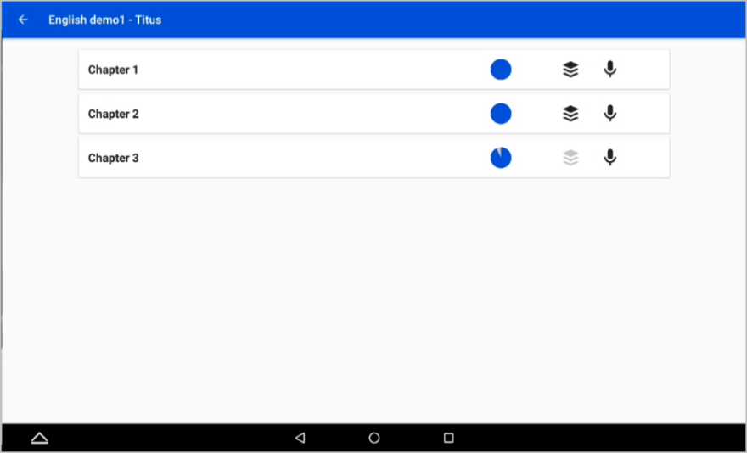

Notice that:

|  |  |
| --- | --- |
|  | The black Compile icon (stack of papers) means that all verses/chunks have recordings. |
|  | The gray Compile icon (stack of papers) means that there are missing recordings. |

### Chapters with a gray Compile icon



For each chapter that is not complete:

1. Tap the Chapter to open the verse/chunk list.  
   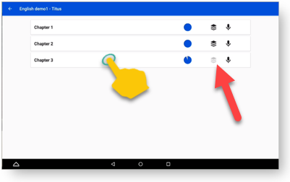
2. Find the verses or chunks that do not have a recording.   
   **HINTS**: There is no arrow next to the microphone. The verse/chunk number is in gray.  
   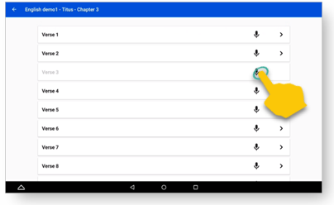
3. Tap the **Microphone** **icon** next to the verse/chunk and record the verse or chunk.

Once all verses or chunks are done, then the chapter is ready to be combined into one audio file. Tap the **back arrow** at the top left of the window to return to the chapter list. The chapter should now be marked with a black stack of paper.

### Chapters with black Compile icon



To create chapter recordings for chapters that are complete, repeat the following 5 steps for each chapter.

1. Tap a bar to open a chapter. Notice full blue circle.   
   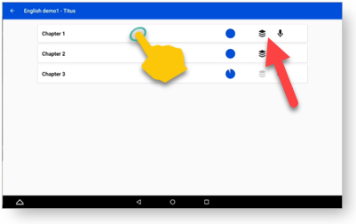
2. Check the recording(s) for each chunk or verse:  
   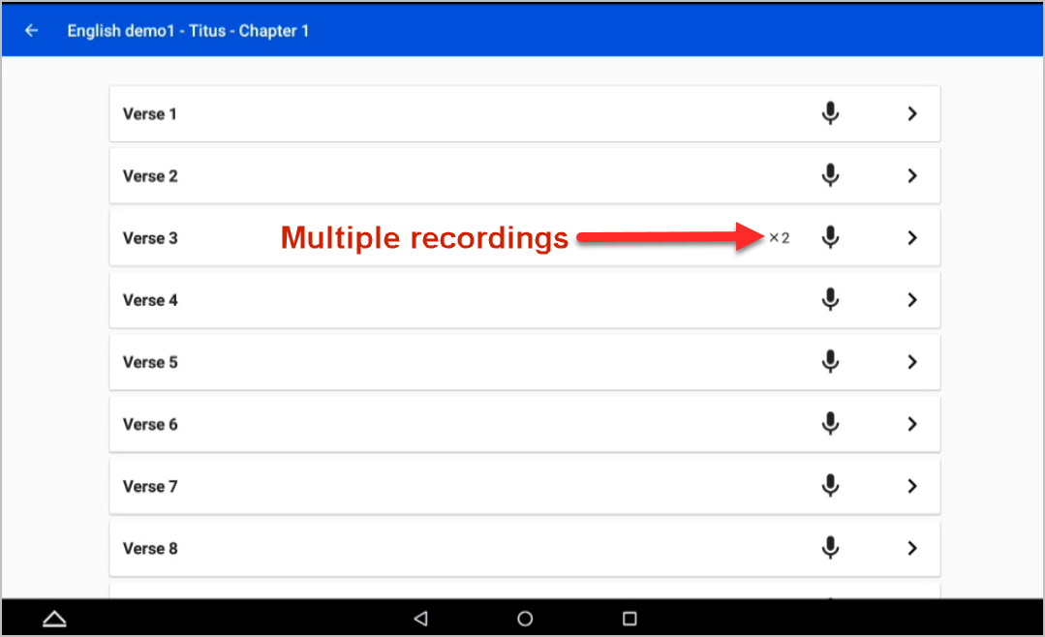 **NOTE**: If there is no number next to the microphone, there is only 1 take per verse/chunk.  
     
   **NOTE**: When there are multiple takes per verse or chunk, there are rules for which take is to be included in the chapter recording. These are the rules followed when combining a chapter into a single audio file:

* If there are recordings with a star rating, they are included according to the number of stars:
  + 3 green stars = first choice (only 1 take per verse or chunk can have a 3-star rating)
  + 2 yellow stars = second choice
  + 1 red star = third choice
* If there is not a star rating given, then a green check shows which take will be used. This is the most recent take. If you want to change this, you can tap the **black checkmark** next to the take you want to use, and then its checkmark turns green and the checkmarks for the other take(s) turn black.  
  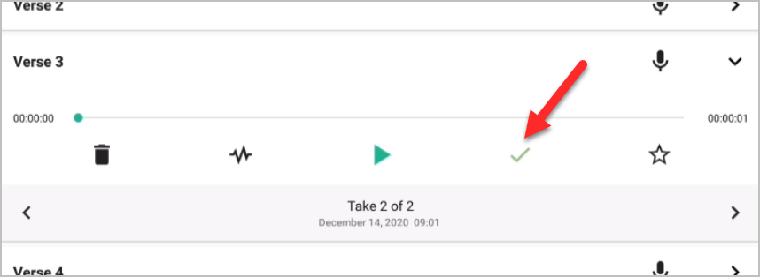

1. Tap the **back arrow** on the top blue bar to return to the chapter listing.  
   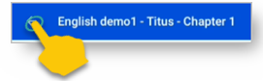
2. Tap the **Stack of Paper icon** to stitch the verse or chunk recordings into one chapter file.   
   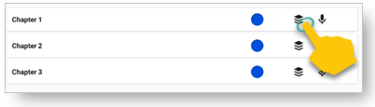
3. Tap **OK** to accept the action of making the chapter into a single file.  
   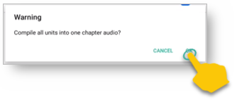

**Remember**: Chapters with a gray Compile icon are not ready to be compiled. Go to Chapters with a gray Compile icon for instructions.

### Check the chapter recording

**NOTE**: Chapters that have been stitched together have a number inside a box icon  on the chapter bar in Project Management.

1. Tap the right arrow (**>**) found at the right end of the chapter bar, to open the Take Bar for the chapter.   
   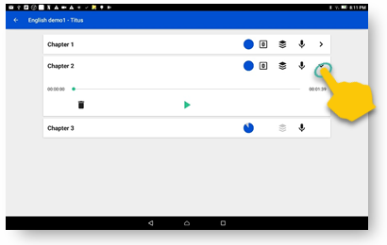
2. 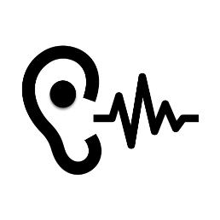Tap the green **Play icon**  to listen to a complete chapter.

***Does the recording need editing?***

**Are there long pauses, or long silences at the beginning or end of the recording?** Go to the verse or chunk recording and delete the silence from the recording.

**Are there things that need to be corrected?** Go to the verse or chunk recording and make a new recording or edit the recording.

When the corrections have been made. Tap the black Compile icon to stitch the chapter again.

### Mark the checking level for the chapter recording

1. Tap the number box to set a level of checking on the audio file.  
   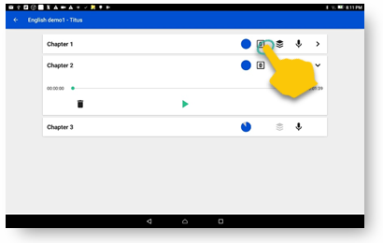
2. Choose a checking level by tapping one of the numbers. 0 is the lowest level while 3 is highest level.  
     
   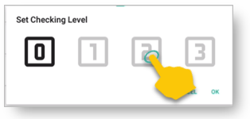
3. Tap **OK** to save the checking level and close the window.

When all the chapters have been compiled, the book is done. Tap the **back arrow** in the top blue bar to return to the Project Management screen.

# Sharing Your Project

After the recordings have been made, edited, and reviewed, they are ready to be exported or   
uploaded so that others can share them. You can:

* Export the completed project to your tablet as a tr file
* Export the completed audio to your tablet as a zip file
* Export the completed audio to another application on your tablet as a zip file
* Upload a project to a Translation Exchange server
* Upload a project to the Citrix ShareFile Server

## Opening the Information window

You can share your recordings from the Information window of the project. To open the Information window:

1. On the Project Manager screen, tap the **Information icon** C:\Users\jarkac.WAOFFICE\OneDrive - Wycliffe Associates, Inc\Shared with Everyone\tRecorder Files\Screen Captures\information icon.png next to the project that you want to export or upload.   
   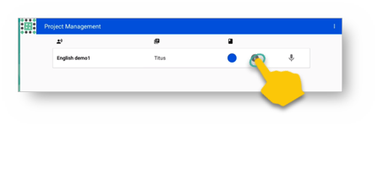
2. The Information window opens. The icons along the bottom right of the window enable you to share your recordings. These icons are explained in the next few paragraphs.  
   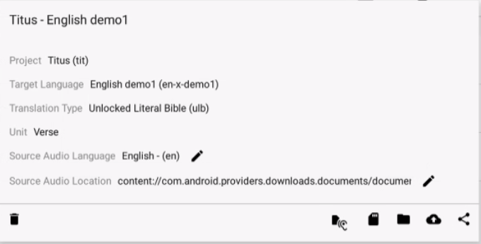

## Export Recordings

### Export to your tablet as a tr file

This action exports the project as a tr file to your tablet. This file can be given to others to import into their installation of BTT Recorder so that they can work on it, or it can be used as a source audio file for BTT Recorder.

To create a tr file on your tablet, perform the following steps:

1. On the Information window, tap the **Source Audio icon**  to save the tr file to the tablet’s file system.  
   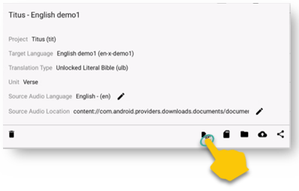
2. A file manager window opens to enable you to navigate to and open the folder where you want to save the tr file. You can save it anywhere in your internal storage or to your SD card. You can also rename the file before saving it if desired.
3. Tap **SAVE** to save the file. If you save it to the SD Card, it can be removed to share the file with others.   
   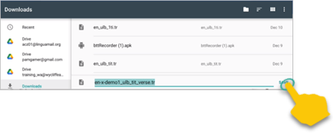

### Export to your tablet as a zip file

This action packages the individual wav files into a single zip file that you can save to your tablet. This file can be given to others or can be imported into Orature software.

1. On the Information window, tap either the **Save icon**  or the **Folder icon**  to save the project file to the tablet’s file system.
2. Wait while the files are processed. The program compiles a zip file containing the individual wav files for each chapter.  
   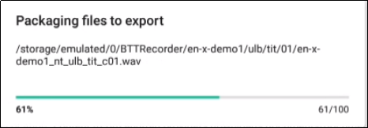
3. A file manager window opens to enable you to navigate to and open the folder where you want to save the zip file. You can save it anywhere to your SD card or in your internal storage. You can also rename the file before saving it if desired.  
   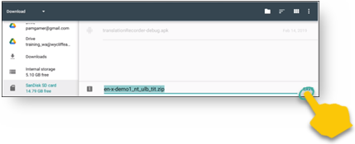  
   **NOTE**: The SD Card may need to be “activated.” Follow the directions provided by the tablet on activating the SD Card so files can be saved there.
4. Tap **SAVE** to save the file. If you save it to the SD Card, it can be removed to share the file with others.

### Export the file to another application

To export the file and have another application immediately use it, such as in an email as an attachment, perform the following steps:

1. On the Information window, tap the **Share icon**  to send the project file to another of the tablet’s applications.
2. Wait while the files are processed. The program compiles a zip file containing the individual wav files for each chapter.  
   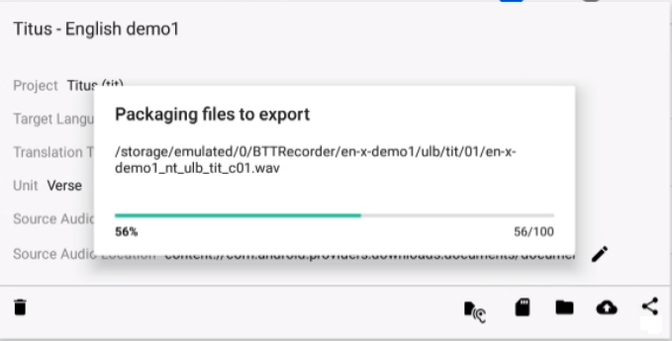
3. A window opens to show the available applications on your tablet that you can use for sharing. Tap the one you wish to open, such as Gmail.  
   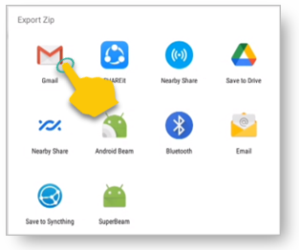
4. The chosen application opens – for example, Gmail opens a compose window with a zip file of the project audio already attached so that you can easily send it to someone.  
   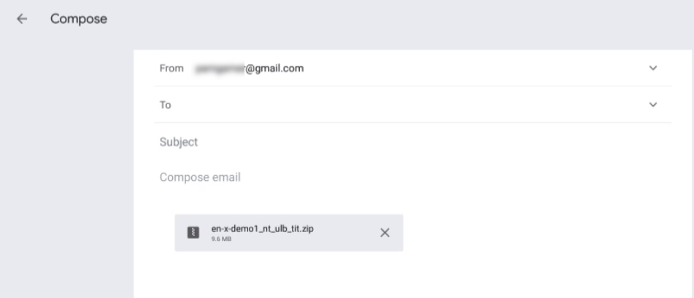

## Upload Recordings

### Upload to Translation Exchange

Translation Exchange is a storage and checking program for audio files. If you have access to a Translation Exchange server, you can upload to it directly by completing the following steps:

1. On the Information window, tap the **Cloud icon**  to upload the project file to the Translation Exchange server.  
   **NOTE:** This is the server defined in the Upload Server setting. See Settings Menu.  
   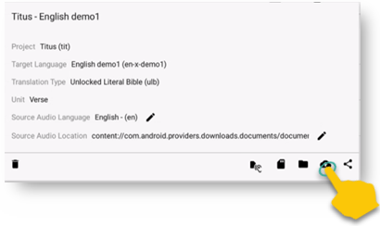
2. The program generates and uploads the file to Translation Exchange.  
   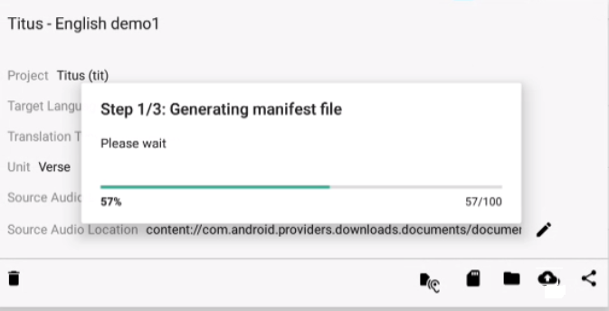  
     
   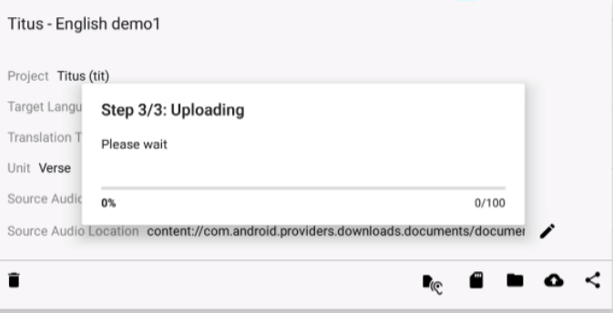
3. The file has been uploaded. Optionally, you can open Translation Exchange to see that it is there.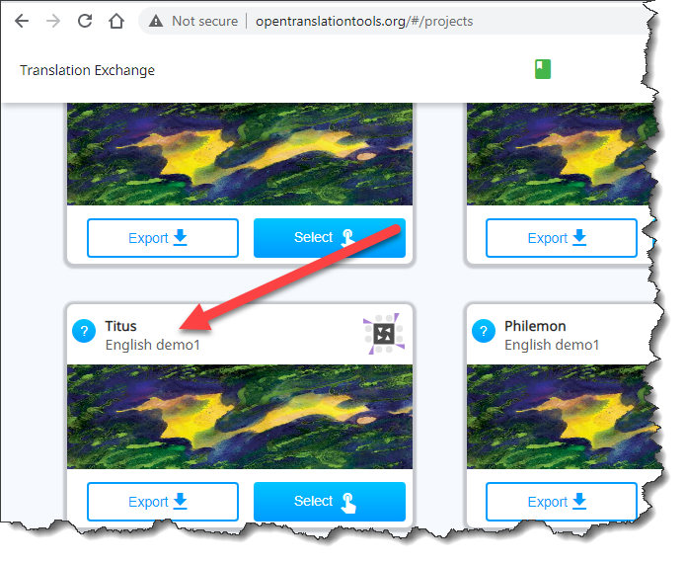

### Upload to the Citrix Server

This final method of sharing your recordings does not use the Information window. You must have a ShareFile account on the Citrix server to be able to store files there.

In a browser on the tablet that has the BTT Recorder files, open the ShareFile server (<https://digitalstorage.sharefile.com>) using your login and password.  
  
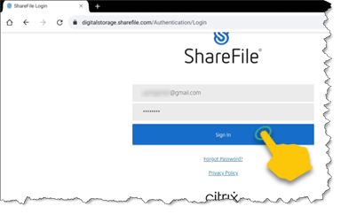

To upload to the Citrix server, you perform the following steps:

1. Find the folder for the files on the Citrix server
2. Create the Bible book folder
3. Create chapter folders
4. Upload chapter recordings to the chapter folders

#### Find the folder for the files on the Citrix server

1. Tap the folder for target language of your project. The folders are shown under the region and/or country of the language.   
   You can first tap the **Magnifying glass icon**  to search for the target language if desired.  
   For example**,** if the target language of your project is Chickasaw, tap the **Magnifying glass** **icon** and type “**Chickasaw**” in the search box, and then tap **Sea**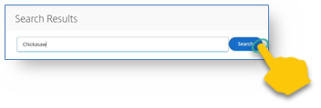
2. The search results are returned. It shows that the Chickasaw folder is found in the Americas/United States folder. Tap the Chickasaw folder to open it.  
   **Hint:** If you will be using that folder frequently, you can tap the star next to it to mark it as one of your favorites.  
   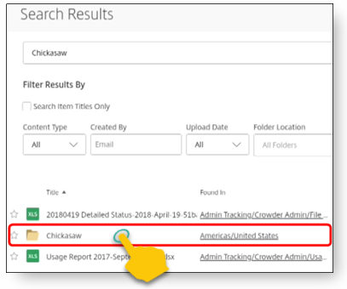
3. The Chickasaw folder is empty, so you need to create a folder structure to store the files. Instructions for that in the next section entitled Create the folder structure.   
     
   However, if you are in a folder that has the folder structure already set up, tap the **Oral folder** in the language that you are recording. The example below shows the structure of the Tamil language folder.
4. Tap the appropriate testament folder – **OT** for an Old Testament book, or **NT** for a New Testament book.  
   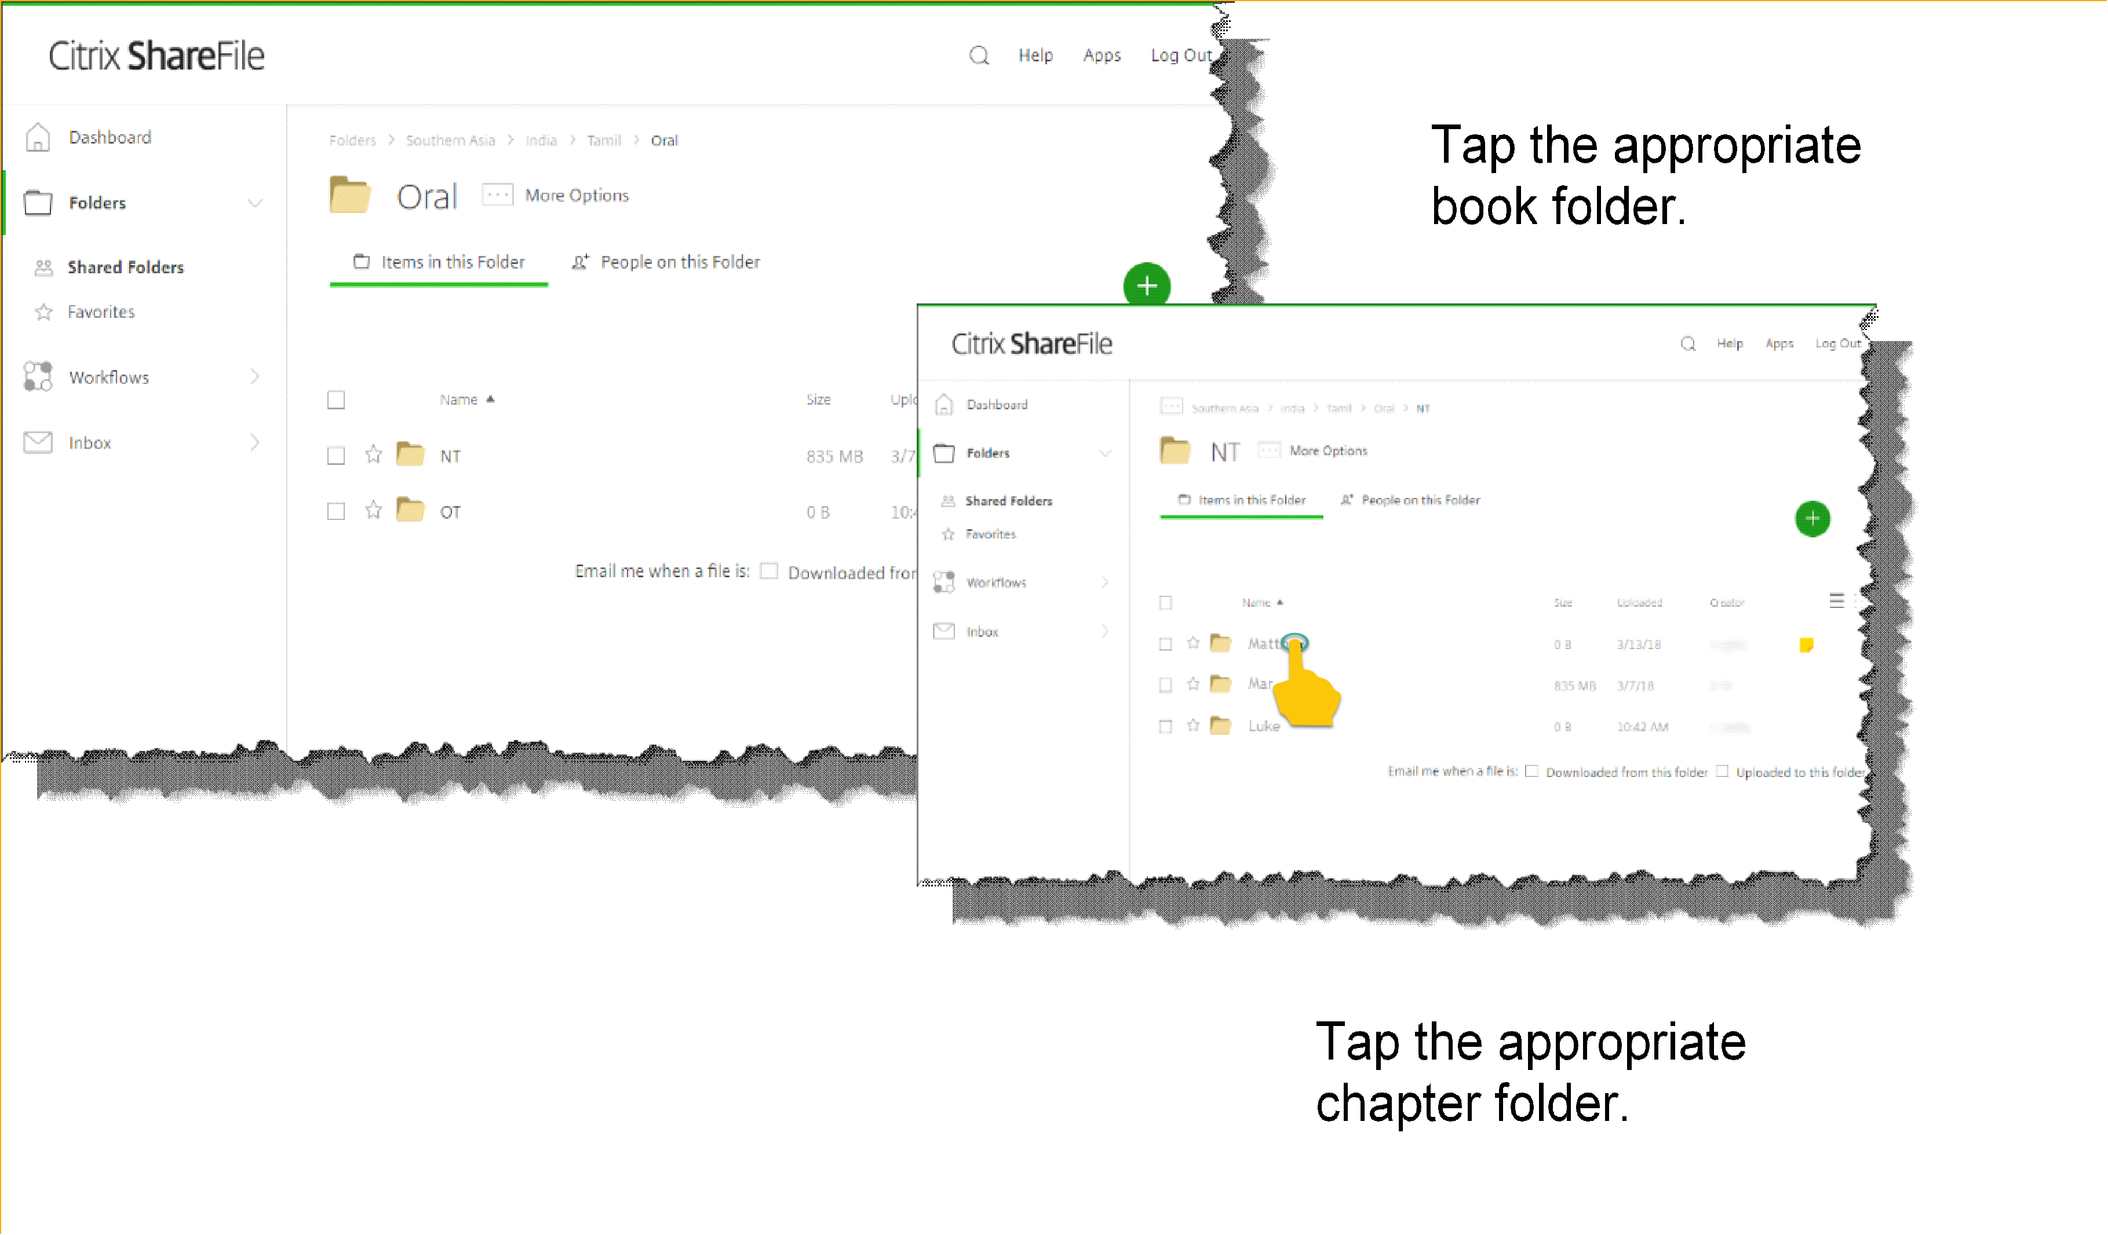

#### Create the folder structure

If the folder structure for the language does not exist, you need to create it.

1. Tap to open the language folder.  
   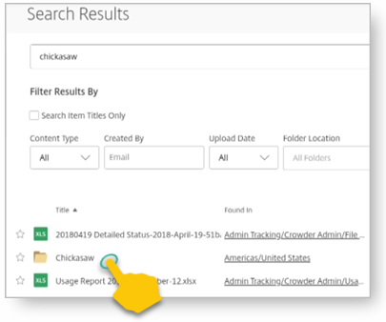
2. Tap the **Plus icon** .  
   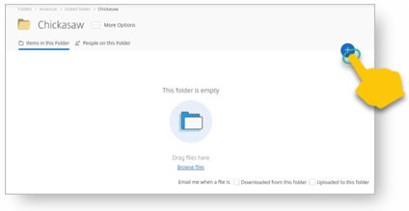
3. Tap **Create Folder** on the menu.  
   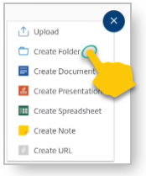
4. Tap in the Name field and type **Oral**, and then tap **Create Folder**.  
   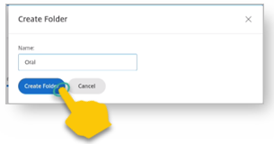
5. In the Oral folder, create the testament folder (OT or NT).
6. In the testament folder, create a folder for the book of the Bible. You should name it with a leading identification number
7. Tap in the Name field and type the book name with the leading identification number. You may use the language’s name for the folder if the identifying number is there (such as 42-Markos for Spanish).  
   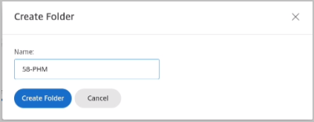  
   See the list of biblical book identification codes – 2-digit number and 3-letter.  
   For example, the 2nd New Testament book for the Spanish Bible would be 42-MRK (or 42-Markos if you use the Spanish name with the leading identification code).
8. Tap **Create Folder**. The new folder is created and opened.
9. Create Chapter folders – one for each chapter in the book. To create a new chapter folder:
10. In the Bible book folder, tap the **Plus icon** .
11. Tap **Create Folder** in the menu.
12. Tap in the ‘Name’ field and enter the chapter number as 2 digits, with a leading zero for single-digit numbers (see table entitled “Global Standard Nomenclature for Books in the Bible” below).
13. Tap the blue **Create Folder button**. The new folder is created and opened.  
    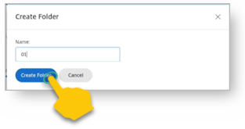
14. To return to the book folder to create another chapter folder, tap the book name in the top breadcrumbs.  
    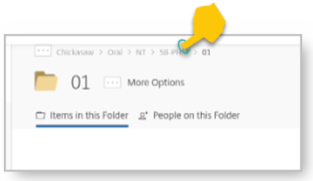
15. Repeat steps a) through e) to create a folder for each chapter.

|  |  |  |  |  |  |  |
| --- | --- | --- | --- | --- | --- | --- |
| **Global Standard Nomenclature for Books in the Bible** | | | | | | |
| 01-GEN | 11-1KI | 21-ECC | 31-OBA | 41-MAT | 51-PHP | 61-1PE |
| 02-EXO | 12-2KI | 22-SNG | 32-JON | 42-MRK | 52-COL | 62-2PE |
| 03-LEV | 13-1CH | 23-ISA | 33-MIC | 43-LUK | 53-1TH | 63-1JN |
| 04-NUM | 14-2CH | 24-JER | 34-NAM | 44-JHN | 54-2TH | 64-2JN |
| 05-DEU | 15-EZR | 25-LAM | 35-HAB | 45-ACT | 55-1TI | 65-3JN |
| 06-JOS | 16-NEH | 26-EZK | 36-ZEP | 46-ROM | 56-2TI | 66-JUD |
| 07-JDG | 17-EST | 27-DAN | 37-HAG | 47-1CO | 57-TIT | 67-REV |
| 08-RUT | 18-JOB | 28-HOS | 38-ZEC | 48-2CO | 58-PHM |  |
| 09-1SA | 19-PSA | 29-JOL | 39-MAL | 49-GAL | 59-HEB |  |
| 10-2SA | 20-PRO | 30-AMO | * | 50-EPH | 60-JAS |  |

*The number 40 is skipped

Now that you have the folders set up, you can upload your recordings to them. Translators typically upload from their tablets; however, a MAST technical support person may harvest the audio files from a tablet to a thumb drive and then use the computer to upload them. Both methods are discussed below.

#### Upload chapter recordings from the tablet

1. Navigate to the correct language, book and chapter folder. If they are not present – see the instructions to create the folder structure.
2. Tap the chapter folder.  
   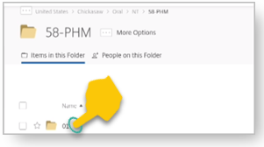
3. Tap the **Plus icon** .
4. Tap **Upload** on the menu.   
   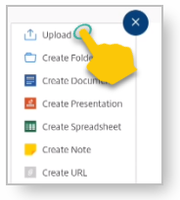
5. The Upload window opens. Tap **Browse files**.  
   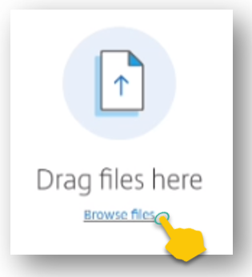
6. A file manager window opens. Tap in turn the following folders:
   1. On the left section, tap **Internal Storage**.  
      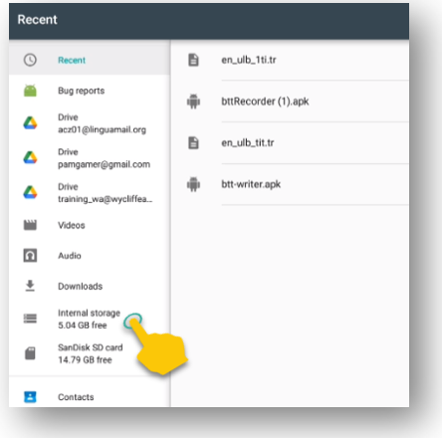
   2. On the right section:
      1. Tap **BTTRecorder**.  
         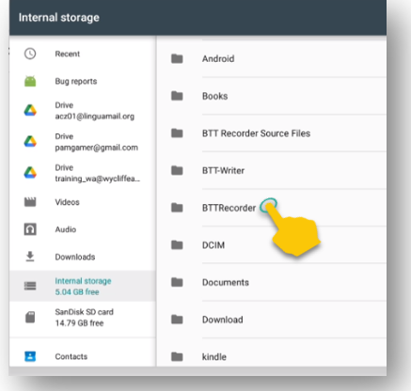
      2. Tap your target language code.  
         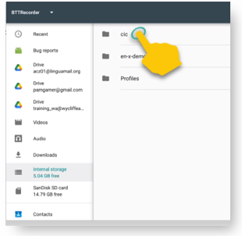
      3. Tap the project type.  
         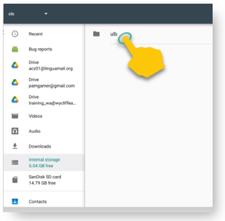
      4. Tap the book code.  
         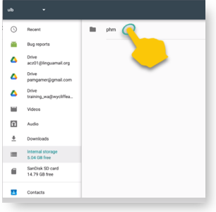
      5. Tap the chapter number.   
         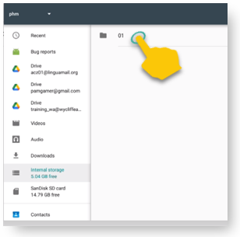
   3. The chapter folder opens and shows all the verse recordings for that chapter.   
      Do a long tap on one of the files (tap and hold until the file’s bar turns darker), and then tap each of the other files to select all of them
   4. Tap **OPEN** at the top right of the screen.  
      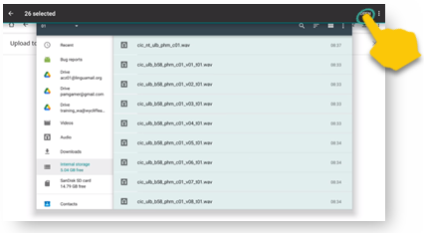
   5. The list of files appears in the ShareFile window. Tap **Upload** to upload the files.  
      **Note**: This screen may not appear – it may upload the files automatically.

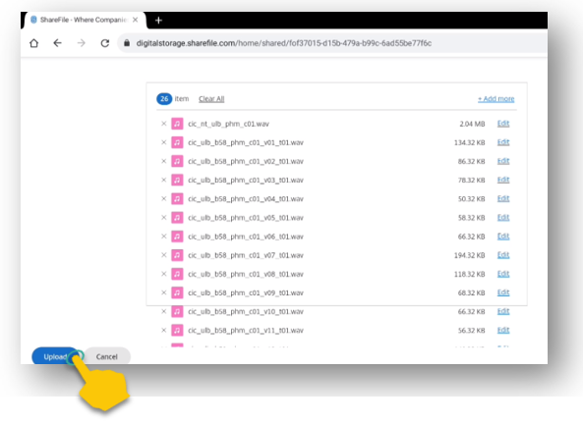

* 1. It may take some time to upload the files.  
     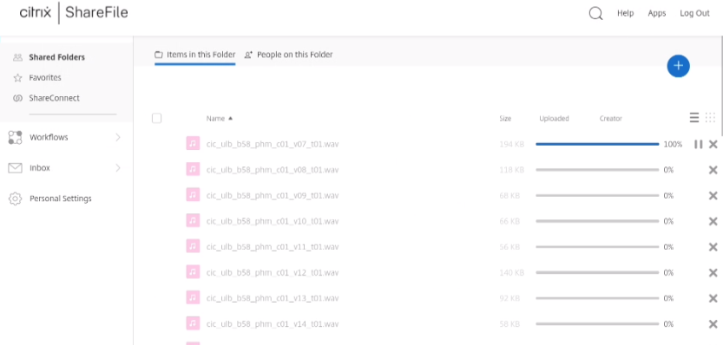  
     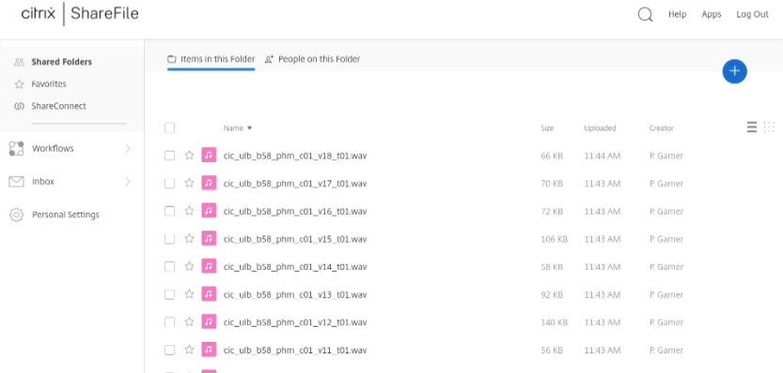

#### Upload chapter recordings from the computer

*These steps assume that a MAST Tech Support Person, or someone working on the recordings, has harvested the files from the tablets onto a thumb drive.*

In a browser on the computer that has the BTT Recorder files, open the ShareFile server (<https://digitalstorage.sharefile.com>) using your login and password.

Follow these steps to add files to a folder on the ShareFile server.

1. Navigate to the correct Language, Book and Chapter folder.
2. Tap the Chapter folder to open it.
3. Tap the **Plus icon** .
4. Tap **Upload** on the menu.

The Upload window opens. There are 2 ways to upload the files:

1. Browse to files:
   1. Click **Browse files**.
   2. Use the File Explorer to browse to the files on the thumb drive or computer’s hard drive.
   3. Select the desired files and click **Open**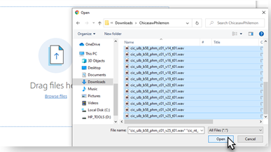
   4. On the Upload window on ShareFile, click **Upload**. Wait while the files upload to the server.

OR

1. Drag the files from the File Explorer.
   1. Open File Explorer and browse to the files on the thumb drive or computer’s hard drive.
   2. Select the files and click-hold-and-drag the files to the browser window. Release the mouse button when you see the words “Drop files here”.   
      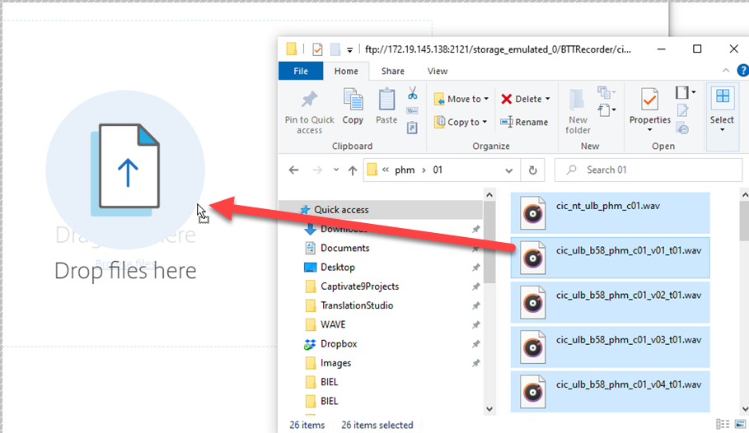
   3. Wait while the files upload to the server.

Repeat these steps for all audio files in each of the chapters.

# 

# Appendix

## Edit Screen Icons

|  |  |
| --- | --- |
|  | **Flag:** Add verse markers. |
|  | **Star**: Rate the recording. Choose between 1, 2 or 3 stars. |
|  | **Re-record**: Open a new recording window. |
|  | **Add a Recording**: Inserts a recording in a selected spot on timeline. |
| **00:00:00** | **Timer**:Shows the passage of time of the recording in hour:minute:second. The smaller numbers after the slash (/) show the total time length of the recording. |
|  | **Rewind**: Go back to the start of the recording. |
|  | **Play**: Listen to the recording. |
|  | **Forward**: Go to the end of the recording. |
|  | **Flag**: Mark a section to cut from the recording. |
|  | **SD Card**:Save the recording. |
|  | **Recording Waveform**:Switch to the Target Language recording. |
|  | **Listening Ear:** Switch to the Source Audio recording. |

## English Source Audio Link

Go to this directory (<https://digitalstorage.sharefile.com/share/view/s34cb4b0a5be4ce3a>) for a list of links to download the English source audio files for BTT Recorder.

**NOTE** These files are for translation projects for the **ULB by Verse**.

How to download:

1. Go to the link above.

Navigate to the desired book/chapter for the translation work.

Tap the desired file.

Download the file to the tablet (or computer to transfer to the tablet later.)

## Translator Handouts

Use these files to give to the oral-only translators to help them remember the steps.

[Recording with Source Audio v1.4](https://github.com/WycliffeAssociates/btt-recorder-docs/raw/master/appendix/BTTRecorder_Recording_with_Source_Audio_1.4.pdf)

[Recording without Source Audio v1.4](https://github.com/WycliffeAssociates/btt-recorder-docs/raw/master/appendix/BTTRecorder_Recording_without_Source_Audio_1.4.pdf)

[Editing Audio Recordings v1.4](https://github.com/WycliffeAssociates/btt-recorder-docs/raw/master/appendix/BTTRecorder_Editing_Audio_Recordings_v1.4.pdf)

[Edit Screen Icons](https://github.com/WycliffeAssociates/btt-recorder-docs/raw/master/appendix/BTT-Recorder_Edit_Screen_Icons_v1.4.pdf)

[Marking Verses in Chunk Mode](https://github.com/WycliffeAssociates/btt-recorder-docs/raw/master/appendix/BTTRecorder_Marking_Verses_in_Chunk_Mode_v1.4.pdf)

[Create Chapter Recordings](https://github.com/WycliffeAssociates/btt-recorder-docs/raw/master/appendix/BTTRecorder_Create_Chapter_Recording_v1.4.pdf)

[Sharing the Audio Files](https://github.com/WycliffeAssociates/btt-recorder-docs/raw/master/appendix/BTTRecorder_Sharing_the_Recording_v1.4.pdf)

[Good Recording Levels](https://github.com/WycliffeAssociates/btt-recorder-docs/raw/master/appendix/BTTRecorder_Good_Recording_v1.4.pdf)

## Video Demonstrations

[Installing BTT Recorder on an Android Tablet](https://youtu.be/L3f7UPdPjSI)

[Creating a New User Profile in BTT Recorder](https://youtu.be/BKADuEH8TVk)

[How to Log Out and Log In for BTT Recorder](https://youtu.be/OcdluzgQazs)

[Creating a New Recording Project in BTT Recorder](https://youtu.be/OpdGF8L7YdI)

[Inserting a Section into a Recording in BTT Recorder](https://youtu.be/kgNQmFu_XAM)

[Deleting a Section from a Recording in BTT Recorder](https://youtu.be/1C-7qk4na6w)

[Inserting Verse Markers in BTT Recorder](https://youtu.be/u_CnbaF6T9U)

[Compiling a Chapter Recording in BTT Recorder](https://youtu.be/NFEh85VwZ34)

## Power Point Presentations (with PDFs)

|  |  |  |
| --- | --- | --- |
| **Title** | **Powerpoint** | **PDF** |
| **Installing BTT Recorder 1.4** | [PowerPoint](https://github.com/WycliffeAssociates/btt-recorder-docs/raw/master/appendix/BTTRecorder_Installing_v1.4.x.pptx) | [PDF](https://github.com/WycliffeAssociates/btt-recorder-docs/raw/master/appendix/BTTRecorder_Installing_v1.4.x.pdf) |
| **BTT Recorder User Setup 1.4** | [PowerPoint](https://github.com/WycliffeAssociates/btt-recorder-docs/raw/master/appendix/BTTRecorder_User_Setup_1.4.pptx) | [PDF](https://github.com/WycliffeAssociates/btt-recorder-docs/raw/master/appendix/BTTRecorder_User_Setup_1.4.pdf) |
| **BTT Recorder Menus and Icons 1.4** | [PowerPoint](https://github.com/WycliffeAssociates/btt-recorder-docs/raw/master/appendix/BTTRecorder_Menus_and_Icons_v1.4.pptx) | [PDF](https://github.com/WycliffeAssociates/btt-recorder-docs/raw/master/appendix/BTTRecorder_Menus_and_Icons_v1.4.pdf) |
| **Starting a New Project using the Recording Section 1.4** | [PowerPoint](https://github.com/WycliffeAssociates/btt-recorder-docs/raw/master/appendix/BTTRecorder_Starting_a_New_Project_Record_Section_v1.4.x.pptx) | [PDF](https://github.com/WycliffeAssociates/btt-recorder-docs/raw/master/appendix/BTTRecorder_Starting_a_New_Project_Record_Section_v1.4.x.pdf) |
| **Starting a New Project using Project Management 1.4** | [PowerPoint](https://github.com/WycliffeAssociates/btt-recorder-docs/raw/master/appendix/BTTRecorder_Starting_a_New_Project_Project_Management_v1.4.pptx) | [PDF](https://github.com/WycliffeAssociates/btt-recorder-docs/raw/master/appendix/BTTRecorder_Starting_a_New_Project_Project_Management_v1.4.pdf) |
| **Recording from Project Management - Oral Translations - WITHOUT source audio 1.4** | [PowerPoint](https://github.com/WycliffeAssociates/btt-recorder-docs/raw/master/appendix/BTTRecorder_Recording_from_PM-Audio_Recordings_Without_Source_Audio%20v1.4.pptx) | [PDF](https://github.com/WycliffeAssociates/btt-recorder-docs/raw/master/appendix/BTTRecorder_Recording_from_PM-Audio_Recordings_Without_Source_Audio%20v1.4.pdf) |
| **Editing in Project Management 1.4** | [PowerPoint](https://github.com/WycliffeAssociates/btt-recorder-docs/raw/master/appendix/BTTRecorder_Editing_Project_Management_v1.4.pptx) | [PDF](https://github.com/WycliffeAssociates/btt-recorder-docs/raw/master/appendix/BTTRecorder_Editing_Project_Management_v1.4.pdf) |
| **Editing Recordings - Cutting and Inserting 1.4** | [PowerPoint](https://github.com/WycliffeAssociates/btt-recorder-docs/raw/master/appendix/BTTRecorder_Editing_Cutting_and_Inserting_v1.4.pptx) | [PDF](https://github.com/WycliffeAssociates/btt-recorder-docs/raw/master/appendix/BTTRecorder_Editing_Cutting_and_Inserting_v1.4.pdf) |
| **Editing Recordings - Verse Markers and Rating 1.4** | [PowerPoint](https://github.com/WycliffeAssociates/btt-recorder-docs/raw/master/appendix/BTTRecorder_Editing_VerseMarkers_and_Rating_v1.4.pptx) | [PDF](https://github.com/WycliffeAssociates/btt-recorder-docs/raw/master/appendix/BTTRecorder_Editing_VerseMarkers_and_Rating_v1.4.pdf) |
| **Create Chapter Recordings 1.4** | [PowerPoint](https://github.com/WycliffeAssociates/btt-recorder-docs/raw/master/appendix/BTTRecorder_Create_Chapter_Recording_v1.4.pptx) | [PDF](https://github.com/WycliffeAssociates/btt-recorder-docs/raw/master/appendix/BTTRecorder_Create_Chapter_Recording_v1.4_PPT.pdf) |